Surface Energy Budget Calculations

Jason E. Box
Department of Geography, Atmospheric Sciences Program
The Ohio State University, Columbus, Ohio, USA
Box.11@osu.edu

Version: November 14, 2006

Contents
1. Introduction 2
2. Data 2
2.1 Shortwave Radiation Data 4
2.2 Profile Data 4
3. Methods 5
3.1 Surface Energy Budget Closure 5
3.2 Net Radiation 5
3.3 Profile Method-derived Turbulent Energy Fluxes 6
3.4 Bulk Method-derived Turbulent Energy Fluxes 8
3.5 Sub-surface Conductive Energy Flux 8
4. Micrometeorological Variables 9
4.1 Aerodynamic roughness length 9
5. Thermodynamic Variables 10
5.1 Virtual Temperature 10
5.2 Water Vapor Pressure 10
5.3 Latent Heat of Vaporization 11
5.4 Specific humidity 11
5.5 Potential Temperature 11
5.6 Virtual Potential Temperature 11
5.7 Air Density 12
6. Works Cited 12

Introduction
The surface energy budget ise useful in characterizing surface climate and weather development, recognizing that the majority of energy that drives weather and climate transfers the surface boundary layer. This report details the methodology to compute surface energy budget components form micrometeorological data.

Data
Data useful in surface energy budget studies can be collected by meteorological instrumentation (Figure 1).
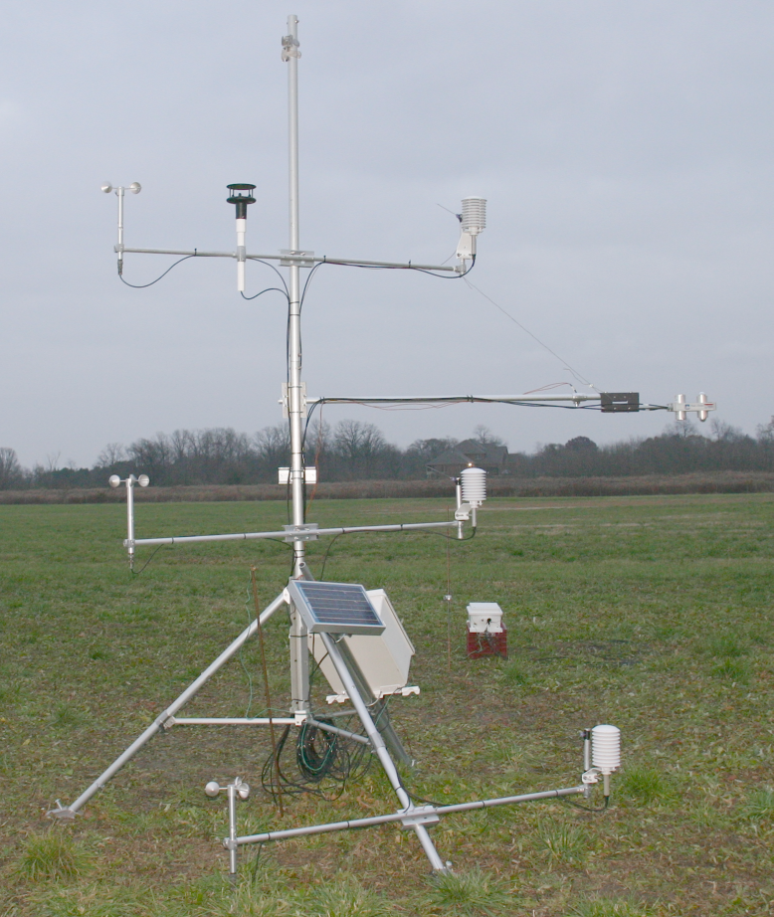
Figure 1. The November 2006 Ohio State University surface energy budget experiment.

The data are 10 minute averages of higher frequency samples summarized in Table 1. Note that level “1” refers to the sensors nearest the surface. Level “2” is thus deeper than level 1 in the ice.
Table 1. Instruments employed in this study by the JAR1 Automatic Weather Station
Parameter | Instrument | Instrument Accuracy | Sampling Interval
air temperature | Vaisala 50YC 1000Ω Platinum Resistance Thermometer | 0.1 °C | 2 s
air temperature | Type-E Thermocouple | 0.1 °C | 2 s
Ground temperature | Platinum Resistance Thermometer | 0.15 °C | 60 s
relative humidity | Vaisala INTERCAP | 5% < 90% RH | 2 s
wind speed | Met One 01a | 0.1 m s⁻¹ | 15 s
station pressure | Vaisala PTB101B | 0.1 hPa | 10 min
Upward and downward solar irradiance | Kipp CM1 as part of CNR1 bundle | variable | 20 s
Upward and downward infrared irradiance | Kipp CG1 as part of CNR1 bundle | variable | 20 s
multiplexer | Campbell Sci. AM-16T | - | -
data logger | Campbell Sci. CR-1000 | - | -

Shortwave Radiation Data
Hourly albedo data include a diurnal ‘cosine-response’ error fluctuation corresponding with instrument sensitivity variations with solar incidence angle. Largest albedo cosine errors occur when solar elevation angles approach zero and the solar irradiance signal is small. Instrument leveling errors also introduce albedo errors. Integrating upward and downward shortwave totals for 24 h periods minimizes both sources of error. ‘Integrated albedo’ (A_{I}), as such, is given by:
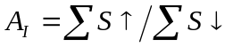
In this study, a single A_{I} value is calculated for each day while van den Broeke et al. (2004) calculate A_{I} as a running mean.

Profile Data
Air temperature, humidity, and wind speed data are available from instrument setup at two levels with 1.02 m separation, capturing ‘aerodynamic profile’ data useful in quantifying vertical transfers of sensible heat energy, moisture, and momentum (e.g. Arya, 2001). At the time of instrument installation, several hours of data can be collected from the profile instruments placed at the same height (~2 m) to evaluate relative data uncertainties. If biases are within manufacturers’ specifications, relative calibration adjustments may not be needed.
Solar overheating of the ‘naturally aspirated’ radiation shields can occur during cases of near-zero wind speed and solar irradiance greater than ~100 W m². The effect of this error on surface energy budget calculations is minimized when wind speed remains above ~4 m s⁻¹ or when direct beam irradiance is small, that is, during overcast conditions.

Methods

Surface Energy Budget Closure
The surface energy budget represents a balance between the surface net radiative energy flux (R_{N}) and the total of the: turbulent sensible energy flux (Q_{H}); turbulent latent energy flux (Q_{E}); and ground conductive flux (Q_{G}). Here, fluxes directed toward the surface-atmosphere interface defined as positive. Thus, for example, evaporative cooling represents a sink of surplus radiative energy and is negative or an air to surface sensible flux is a source of heat to the surface and is positive. A downward conductive flux is negative as it represents a sink of radiation surplus. As such, the residual melt energy (Q_{M}) may be solved, exploiting conservation of energy:

R_{N} + (Q_{H} + Q_{E} + Q_{G}) = Q_{M} + ε

Energy contributions from liquid precipitation (Q_{P}), while not observed by the sensors, are likely to be of secondary importance and are neglected.
Surface energy budget surpluses raise the surface and sub-surface temperatures until, in the case of snow and ice, the melting point is reached. If energy surplus conditions persist, the surplus energy is disposed by the conversion of ice to water. Energy deficits lead to surface cooling and potentially the freezing of water.

Net Radiation
Net radiation, representing one side of the energy ‘balance’, spans the entire wavelengths range significant for heat energy spanning ‘optical’ to ‘thermal infrared’ wavelengths. R_{N} includes two streams, that is, the vertical ‘shortwave’ (S) streams that include ultraviolet, visible, with near infrared and fluxes spanning the 0.3 – 1.4 μm wavelength range. This study refers to downward, upward, and net vertical flux densities (W m⁻²), for example, as, S↓, S↑, S_{N}, for shortwave. Similarly, ‘longwave’ (L) thermal infrared, spanning the 1.4- 150 μm wavelength range, has fluxes also expressed in their downward, upward, and net (L_{N}) vertical streams. R_{N} is thus:

R_{N} = S_{N} + L_{N} = (S↓-S↑)+(L↓-L↑)

Clouds affect the surface radiation budget. However, no direct cloud observations are available from the instrumentation. A qualitative indication of relative cloudiness can be taken from high-frequency hourly variations in S↓ data and nighttime net radiation, the latter being less negative during cloudy conditions. Better is to use cloud observations, for example, from nearby airports.
‘Day’ and ‘night’ statistics can be calculated to investigate the energy budget impacts of day/night surface microclimate, defined as ‘day’ for cases when S↓ exceeded 150 W m⁻², ‘night’ defined for cases when S↓ was less than 150 W m⁻². Time coordinates used in this study have been set to ‘local solar time’ by subtracting the decimal time equivalent of the site longitude from the Universal Time Coordinate (UTC).

Profile Method-derived Turbulent Energy Fluxes
Turbulent energy fluxes can be derived using a ‘Profile Method’ given data from at least two levels (Thornthwaite and Holtzmann 1939). The turbulent sensible heat flux (Q_{H}) was calculated using Eq. 5 given temperature and wind speed profile data using Monin and Obukhov (1954) similarity theory (see e.g., Oke, 1987):

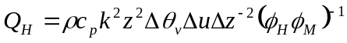

where  is the air density; c_{p} is the specific heat of the air, taken as 1005 J kg⁻¹; k is the von Kármán constant, taken as 0.4; z is the ‘geometric mean’ height of the observations, that is, 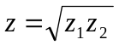; 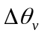 is the hourly mean vertical potential virtual temperature difference, that is, 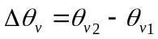, in Kelvins, where 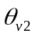 is above 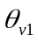; 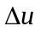 is the hourly mean vertical wind speed difference, that is, 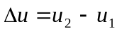, in m s⁻¹ units; 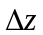 is the instrument spacing, that is, 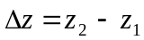, in m units. Instrument heights z₁ and z₂ were calculated using initial instrument heights plus subsequent surface height changes. Finally, 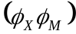 a correction term for departure from the neutral stability flux-gradient theory (e.g. Högström, 1988). Here, the dimensionless evaporative and momentum flux correction 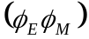 and the dimensionless sensible heat and momentum flux correction 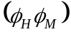 are taken to be equivalent for stable conditions (e.g. Arya, 2001).
The ‘similarity corrections’ may be expressed as functions of The Richardson Number (R_{i}) quantifies the mixing efficiency influence of air buoyancy and wind shear on turbulent heat transfer (e.g. Arya, 2001).
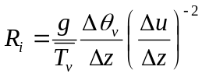

Over surfaces with a temperature inversions, ‘stable stratification’ predominates. The effect of predominantly stable stratification (R_{i} > 0) is on damping turbulent fluxes by an amount approximated by the dimensionless 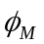 and 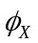 parameters. is the similarity correction for momentum and is the similarity correction for heat (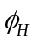) or water vapor (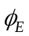). The correction function parameters  and differ in stable and unstable conditions, that is, 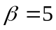 and for stable conditions and 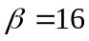 and 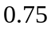 for unstable conditions

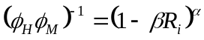
In an analogous way to Q_{H,} turbulent evaporative ‘latent heat flux’ (Q_{E}) was calculated using the Profile Method given humidity, temperature and wind speed profile data:
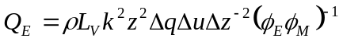
where 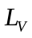 is the latent heat of vaporization (2.501 MJ kg⁻¹); 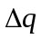 is the mean vertical specific humidity difference, that is, 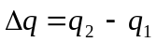, in kg kg⁻¹ units. Note that latent heat fluxes are used to quantify evaporation rates (E), given that E = Q_{E}/L_{V}.

Bulk Method-derived Turbulent Energy Fluxes
The ‘Bulk Method’ after Deardorf (1968) offers an alternative form of profile theory, see also Ishikawa et al. (1992). The bulk method is attractive for use because the vertical temperature and humidity difference between the surface and ~2m is commonly larger than between profile levels of nominally 2m and 3m, respectively. Bulk methods, can thus provide a larger ‘signal to noise’. Furthermore, the Bulk Method latent heat flux requires only one humidity measurement level during melting when it is reasonable to assume that the melting ice surface temperature is near 0°C and is saturated with respect to water vapor. Bulk methods perform realistically in comparison with eddy covariance measurements (Box and Steffen, 2001). Here, level 2 is chosen for application the Bulk Method:

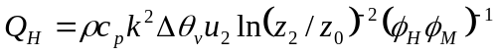

Note that specifying profile level 1 as the reference level, as opposed to level 2, resulted in very similar Bulk turbulent heat fluxes.
The Bulk Method expression for Q_{E} after Deardorf (1968) is:

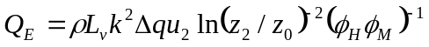

Profile and Bulk Methods are later compared and discussed in terms of uncertainty in turbulent fluxes and surface energy budget closure.

Sub-surface Conductive Energy Flux
Conductive energy flux (Q_{G}) was calculated from sub-surface temperature data using:
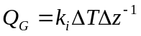
where k_{i} is the thermal conductivity with W m⁻² K⁻¹ units (Oke, 1987), 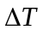is the temperature difference (lower minus upper), and 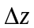 is the 0.5 m instrument separation

Table 2. Thermal properties of natural materials
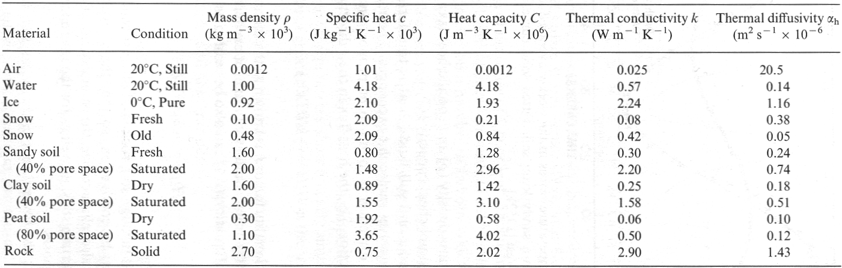
after Arya (2001); Oke (1987); and Garrat (1992)

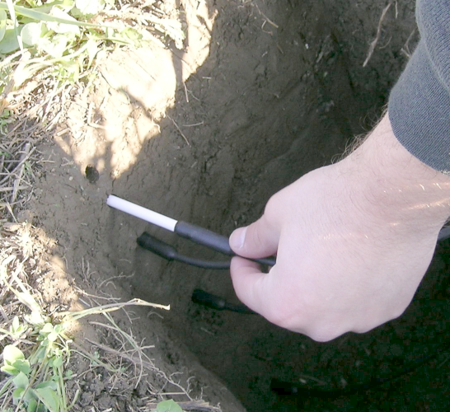
Figure 2. Installation of soil temperature sensors.

Micrometeorological Variables

Aerodynamic roughness length
The Aerodynamic roughness length (z₀, m units) can be computed using the wind speed gradient in logarithmic height coordinates using:
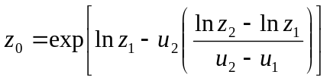

Note that the determination of z0 is probably most accurate during neutral stability. Note that strong winds may deform surface roughness features, yielding a z₀ variation with wind speed.

Thermodynamic Variables

Virtual Temperature
The virtual temperature is the temperature that dry dry air would have if its pressure and density were equal to those of a given sample of moist air [], that is,

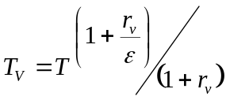
where r_{v} is the water vapor mixing ratio, with kg/kg⁻¹ units and ε is the ratio of the gas constants of air and water vapor, approximately equal to 0.622.
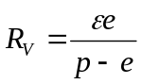

where e is the water vapor pressure, having Pa units.

Water Vapor Pressure

The water vapor pressure (e) , having Pa or hPa units, may be calculated given relative humidity and temperature measurements using:

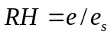
where e_{s} is the saturation vapor pressure, calculated using the formulation of Bolton (1980), to be accurate to within 0.1% over the +/- 30°C range:

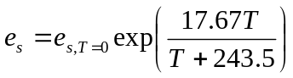

where e_{s,T=0} is 6.112 hPa and T is given in Kelvin units. Thus, e is given by:

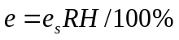

Latent Heat of Vaporization
The latent heat of vaporization is a weak function of temperature, after

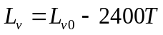

where 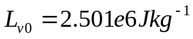 and T is air temperature, given in Celsius units.

Specific humidity
Specific humidity is the (dimensionless) ratio of the mass of water vapor to the total mass of the system, and is given by:
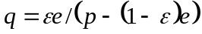
where ε is the ratio of the gas constants of air and water vapor, approximately equal to 0.622, e is the water vapor pressure (either in Pa or hPa units), p is the air barometric pressure (either in Pa or hPa units). Be consistent with pressure units. The specific humidity q is related to the water vapor mixing ratio r_{v} by:

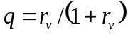

Potential Temperature
The potential temperature 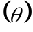is the temperature that an unsaturated parcel of dry air would have if brought adiabatically and reversibly from its initial state to a standard pressure, p₀, typically 1000 hPa, . is given by:
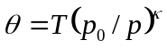
where T is the air temperature in Kelvins units, p is the barometric pressure in Pa units, κ is referred to as the Poisson constant (κ), that is, the ratio κ of the dry gas constant R_{d} (287 W kg⁻¹ K⁻¹) to the specific heat at constant pressure c_{p,} taken as 1005 J kg⁻¹ K⁻¹. For dry air, κ = 0.2854.

Virtual Potential Temperature

The virtual potential temperature 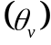 is the theoretical potential temperature of dry air that would have the same density as moist air, and is given by:
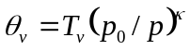
where T_{v} is the virtual temperature in Kelvins units, p is the barometric pressure in Pa units, κ is referred to as the Poisson constant (κ), that is, the ratio κ of the dry gas constant R_{d} (287 W kg⁻¹ K⁻¹) to the specific heat at constant pressure c_{p,} taken as 1005 J kg⁻¹ K⁻¹. For dry air, κ = 0.2854.

Air Density
Air density (kg m⁻³) varies with temperature and pressure, after the following:

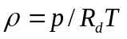

where R_{d} is dry gas constant (287 W kg⁻¹ K⁻¹).

Works Cited
Arya, S. P. 2001. Introduction to Micrometeorology, 307 pp., Academic, San Diego, Calif., 2nd Ed.
Bolton, D. 1980. The computation of equivalent potential temperature, Mon. Wea. Rev., 108, 1046-1053. Eq. 10.
Deardorff, J.W., 1968. Dependence of air-sea transfer coefficients on bulk stability, J. Geophys. Res. 73, 2549-2557.
Garratt, J. R., 1992. The Atmospheric Boundary Layer. Cambridge University Press, 316 pp., ISBN 0521467454
Högström, U. 1988. Nondimensional wind and temperature profiles in the atmospheric surface layer: A re-evaluation, Boundary Lay. Meteorol., 42(1/2), 55-78.
Ishikawa, N., L.F. Owens, and A.P. Sturman. 1992. Heat balance characteristics during fine periods on the lower parts of the Franz Josef Glacier, south Westland, New Zealand, Int. J. Clim., 12, 397-410.
Monin, A.S. and Obukhov, A.M., 1954. Osnovnye zakonomernosti turbulentnogo eremesivanija v prizemnom sloe atmosfery, Trudy geofiz. inst. AN SSSR, 24(151): 163-187.
Stull, R. B., 1988. An Introduction to Boundary Layer Meteorology, 666 pp., Kluwer Acad., Norwell, Mass., USA.
Thornthwaite, C. W., and B. Holzman, 1939. The Determination of evaporation from land and water surfaces, Mon. Weather. Rev., 67, 4-11.
van den Broeke, M., D. van As, C. Reijmer, R. van de Wal. 2004. Assessing and improving the quality of unattended radiation observations in Antarctica, J.. Atmos. and Ocean. Tech, 21(9), 1417–1431.

METAR data available from: http://twister.sbs.ohio-state.edu/metar/ohio/osu/
American Meteorological Society Glossary: http://amsglossary.allenpress.com/glossary/
American Meteorological Society Glossary: http://amsglossary.allenpress.com/glossary/

